* **Idea:**
* **Formal idea name: Simple Banking Processing System**
* **Commercial Name: Bankna**
* **Group Members:**

1. **Mariam Bayoumy**
2. **Monika Atfy**
3. **Ahmed Moustafa**
4. **Michael Ashraf**

* **Description:**

**1) Our system is working on adding new customers.**

**2) Updating balances of existing customers when they add or withdraw from their balances.**

**3) Reading from and Saving all data of customers to an existing locked file.**

* **Features:**

**1) Adding customers**

**2) Modifying customer’s balance data , depending on the employee entering it.**

**3) Counting number of transactions made.**

**4) Counting number of failed transactions made.**

**5) Containing Balance sheet carrying all customers data ( Account numbers , names , Account Balances)**

**6) Exiting on entering the exit keyword.**

* **Technical Description:**

1. **File IO**
2. **Exception Handling**
3. **Streams**

* **Memory:**

**-Primitives no of variables:**

* **Global => 4**
* **Local => 5**

**-Data Structures:**

* **Arrays => 3**
* **Lists => 7**

**-No of loops => 3**

* **Decision Points (number of Branches):**
* **If condition => 18**
* **Modules:**
* **Classes => 1**
* **Methods => 2**
* **Screenshots:**
* **Page (1):**

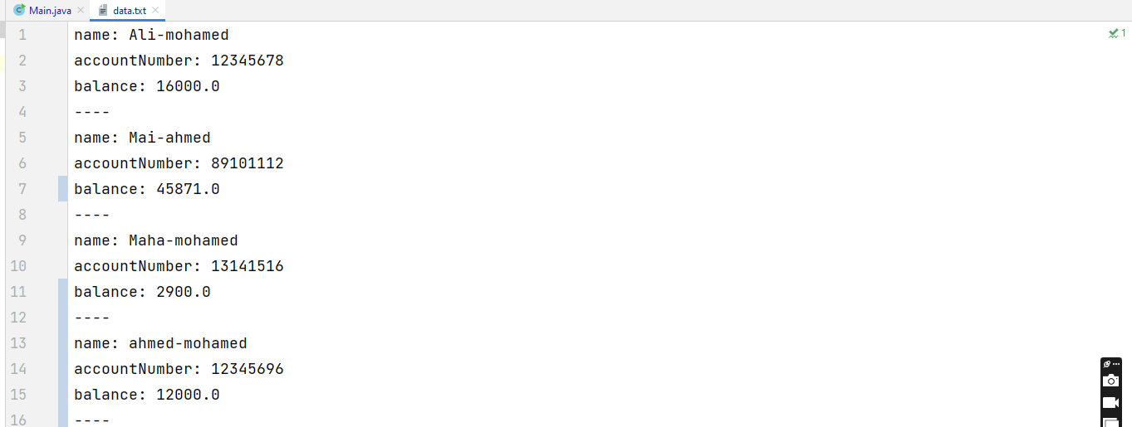

* **Page(2):**

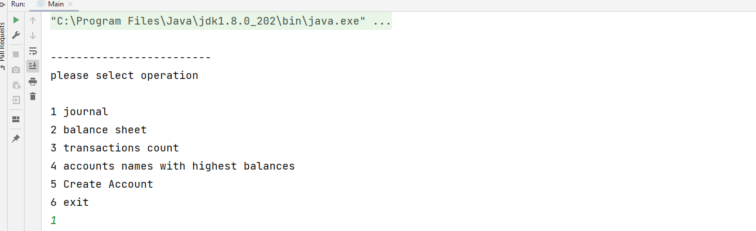

* **Page (3):**

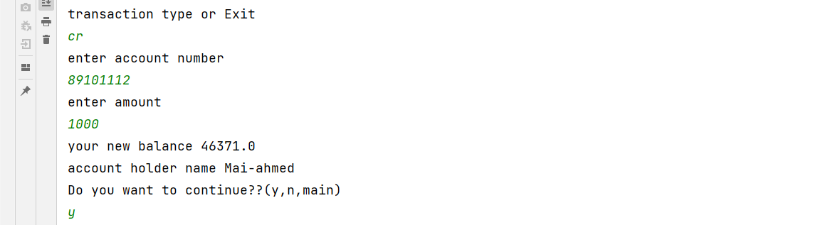

* **Page (4):**

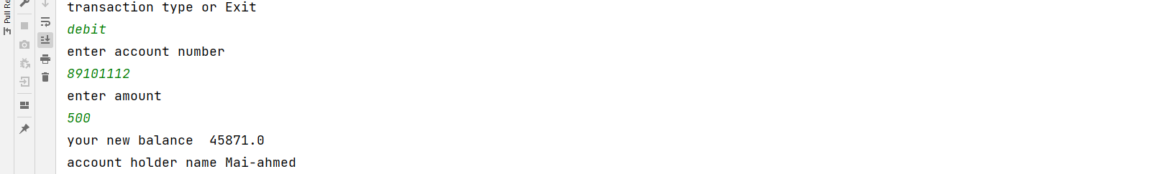

* **Page (5):**

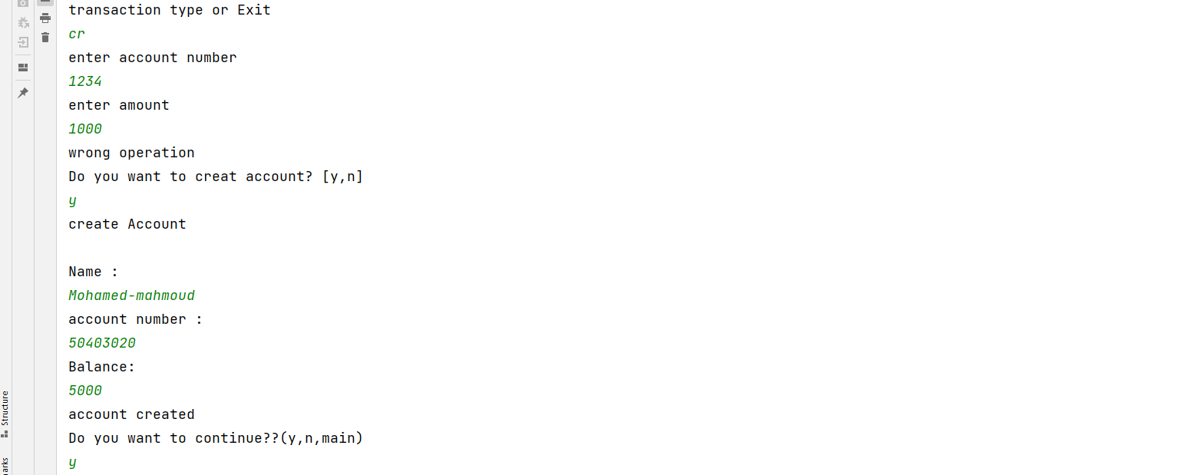

* **Page (6):**

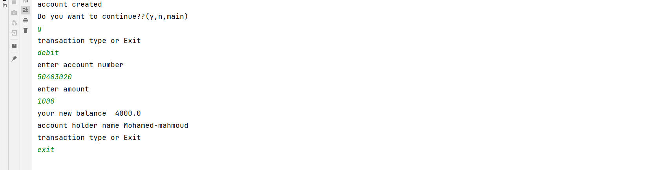

* **Page (7):**

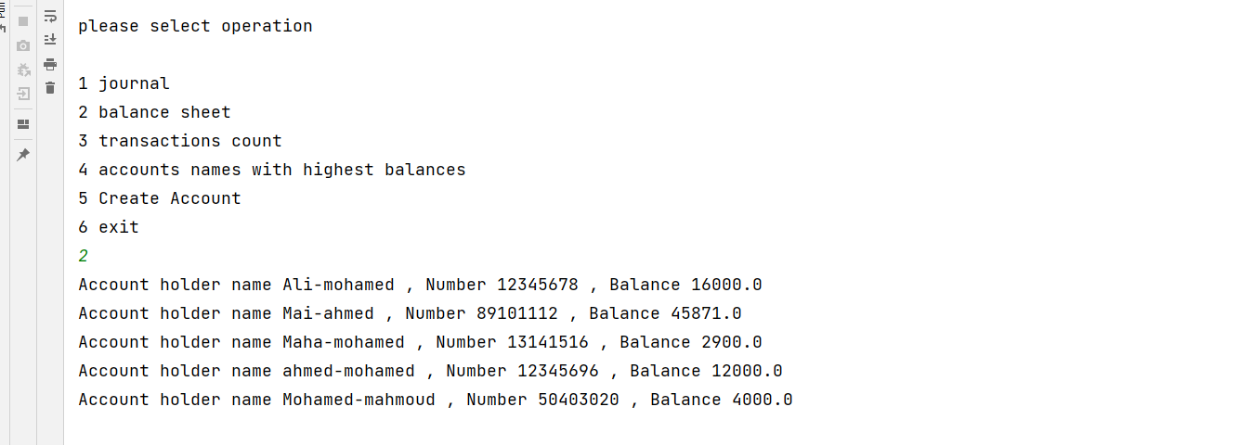

* **Page (8):**

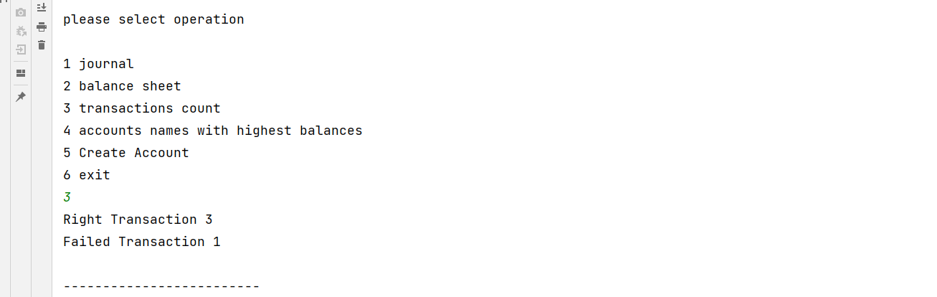

* **Page (9):**

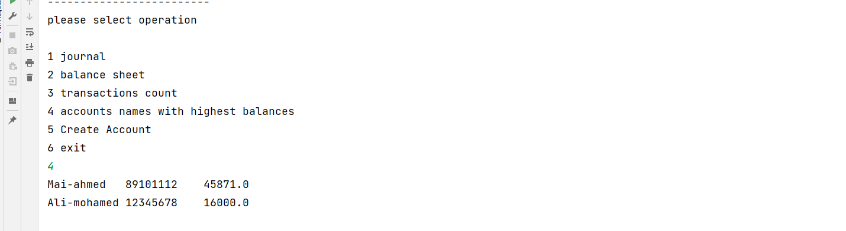

* **Page (10):**

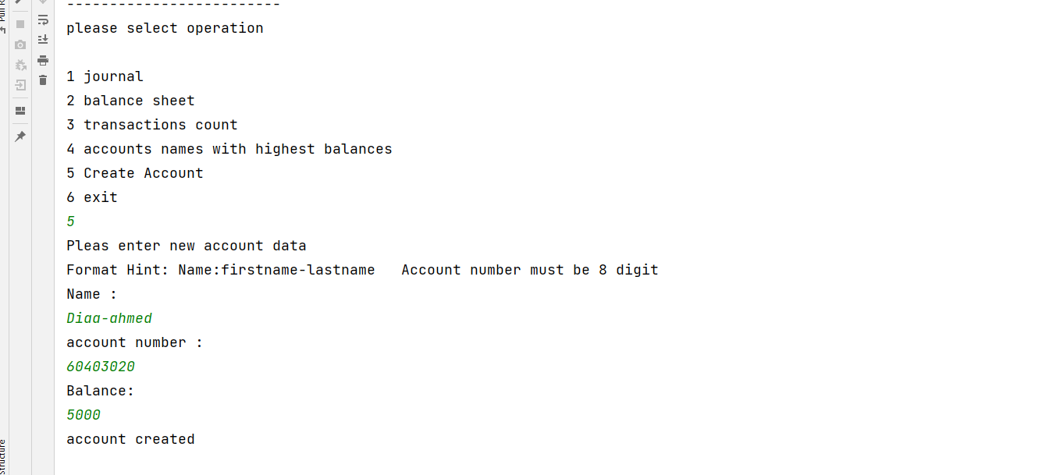

* **Page (11):**

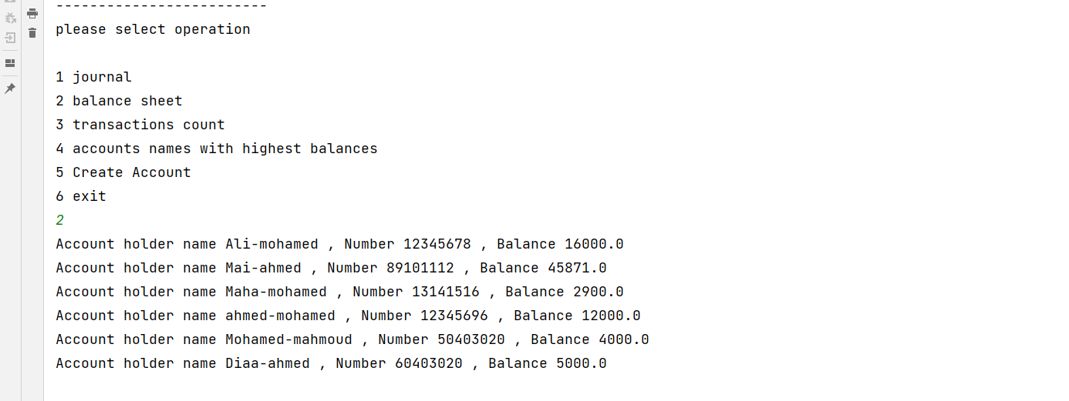

* **Page (12):**

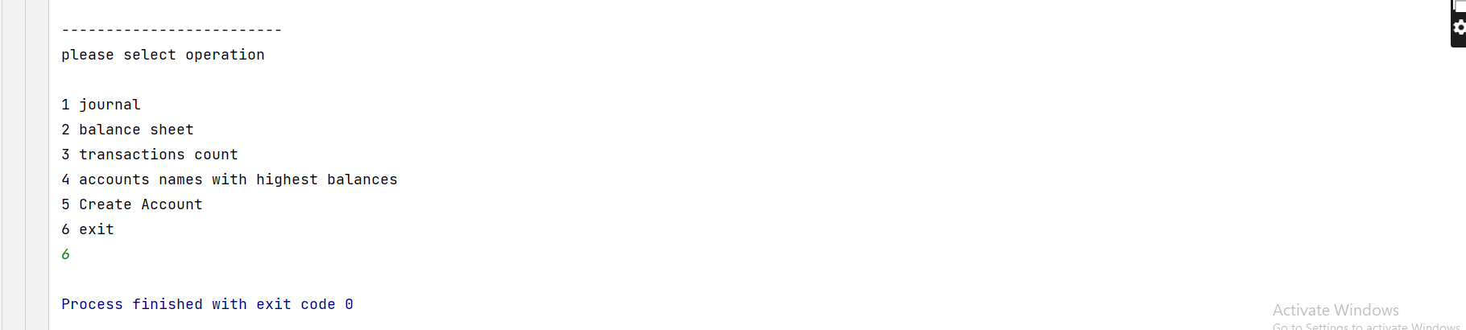

* **Page (13):**

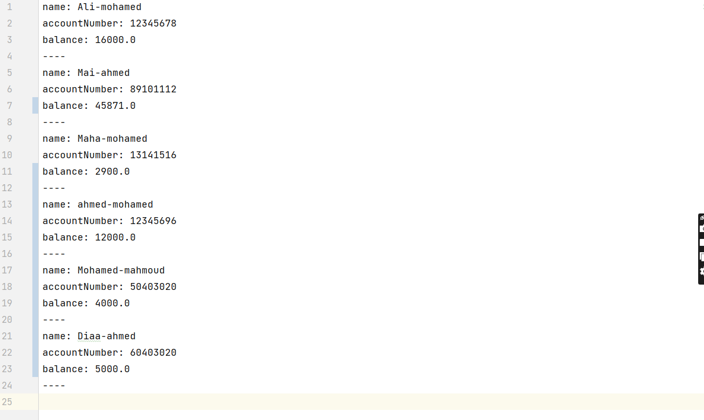

* **Usecase diagram:**

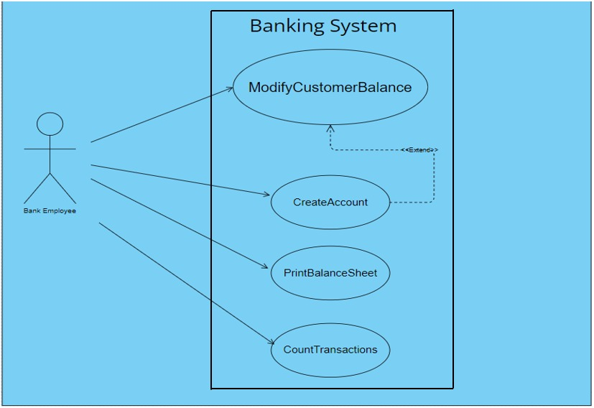

* **Class diagram:**

